**Biotron**

**Hardware Test Plan**

**For Prototype**

|  |  |
| --- | --- |
| **Version** | **1.0** |
| **Owe Dept.** | **WISR** |
| **Originator** | **Tyler Li** |
| **Date** | **2016/09/12** |

1. **Purpose**

This file is to regular testing methods and record testing result, so that we will have detailed data to confirm whether the design is meet our requirement.

1. **System function block frame**

Figure 1. System Block Chart

1. **Testing Devices**

|  |  |  |
| --- | --- | --- |
| DC Source |  |  |
| research grade EMG machine | Biosemi ActiveTwo |  |
| oscilloscope |  |  |
| electrical loader |  |  |
| signal generator |  |  |
| Computer |  |  |
|  |  |  |
|  |  |  |

1. **Functions & Testing Methods**

## Power supply

In this design, we have to supply 3 different voltages for the system, that is DVDD (+3.3V) for digital ICs power consumption, AVDD (+2.5V) and AVSS (-2.5V) as a voltage reference for ADC. So, we will test them in different ways.

### 4.1.1 DVDD testing

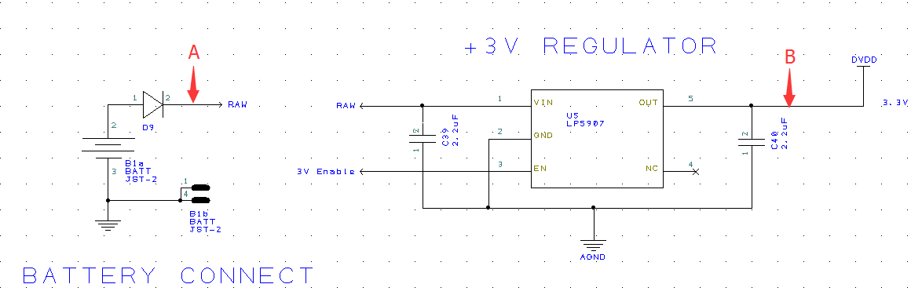

Figure 2. The Schematic chart of DVDD

As the main power supply net, DVDD must be clear and stable. So, we need to test its output characteristics under different inputs condition. Before testing the function block, we need to confirm the diode D9 forwards voltage drop is under control. Since the detailed name of D9 is unknown, so we have to keep it to the last.

### 4.1.1.1 Static Characteristic

At the beginning, we use DC power supply to generate DC voltage at A point (showed in Figure 2), connect “3V Enable” to the signal generator, so that we can control the LP5907, connect B point to the electrical Loader, set the electrical loader in resistor model. The max current consumption of each digital functional circuit is recorded as follows: (assume the max current consumption of power supply circuit is 1mA as those ICs’ current consumption are at μA level.)

Table 1: Current Consumption of each ICs

|  |  |  |  |  |
| --- | --- | --- | --- | --- |
| IC/module | Min (mA) | Type (mA) | Max (mA) | supplement |
| RFDUINO MODULE | / | 16 | / | Transmit 12mA ARM running 4mA |
| PIC32MX250128B | / | 20 | 30 | At 40MHz, not include IO output current. |
| AD1299 | / | 8.14 | / | AVDD needs 7.14mA when AVDD-AVSS=5V DVDD needs 1mA at normal mode |
| SD CARD |  | 30mA |  | Comes from internet. Need confirm. |
| ACCELEROMETER |  | 0.011 |  |  |

So, the DVDD should at least supply 74mA current. We need set it more than 100 mA as conservative estimate. Since the DVDD voltage is 3.3V, we need set the electrical loader’s resistance to 33 ohm.

The input voltage = Battery voltage – Diode forwards voltage drop,

For a cell battery, its rating voltage is 3.7V, usually 3.1V~4.2V (depend on the kind of battery).

For a regular silicon diode, voltage drop will be 0.7V as typical.

So, the A point voltage range will be 2.4V ~3.5V.

Record the data:

Table 2. Output of DVDD under different DC input condition

|  |  |  |
| --- | --- | --- |
| Input voltage (V) | Output voltage (V) | Current (mA) |
| 3.3 |  |  |

Waveform record if needed.

### 4.1.1.2 Dynamic Characteristic

(B) Ripple wave when heavy load.

Using electrical loader to simulate 100mA load, and set the input voltage as 3.7V, record the waveform of point A and B, read out the peak to peak voltage.

WAVEFORM.

Peak to Peak Voltage:

### 4.1.2 AVDD and AVSS testing

Using DC source as DVDD, input into AVDD and AVSS function circuit. Then, record several Waveforms when changing the input voltage. So that we can confirm the stability of the AVDD and AVSS.

WAVEFORM1:

WAVEFORM2:

…

## Sampling Testing

We need to confirm the sampling circuit accuracy so that we can make sure the surface EMG signal can be used.

### 4.2.1 Low Pass filter

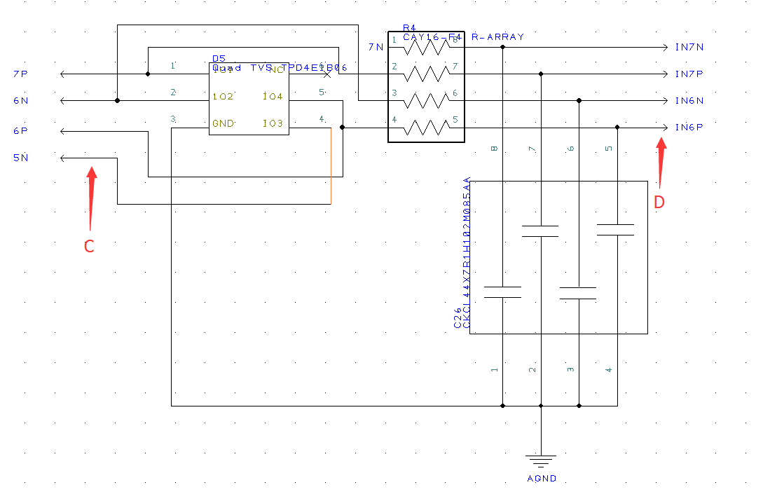

Figure 3. A part of Low Pass filter

As the EMG signal frequency is mainly between 10~500Hz, so the low pass filter should be appropriate for it. The bandwidth should be a little larger than 500Hz, it is often set as 1000Hz or 2000Hz.

So we need to test the low pass filter’s characteristics.

At first, connect 1 channel of sensor to the signal generator. Then, use oscilloscope to monitor point C and D.

Record the waveform and amplitude of input and output signals under different frequencies. Calculate the Gain of the Low Pass filter.

Table 3. Records for voltage amplitude at different frequencies.

|  |  |  |  |
| --- | --- | --- | --- |
| Input voltage (V) | Frequency(Hz) | Output voltage (V) | GAIN |
| 1V | 10 |  |  |
| 1V | 100 |  |  |
| 1V | 500 |  |  |
| 1V | 1000 |  |  |
| 1V | 2000 |  |  |

WAVEFORM:

Also, we can calculate the bandwidth of the filter so that we can adjust the parameter of LP filter.

$$f_{cut_{off}}=\frac{1}{2πRC}$$

So, if we need the cut_off frequency close to 2KHz, the value of R*C should not be larger than 8e-5. Assume C=10 nF, then, R should be 8K ohm.

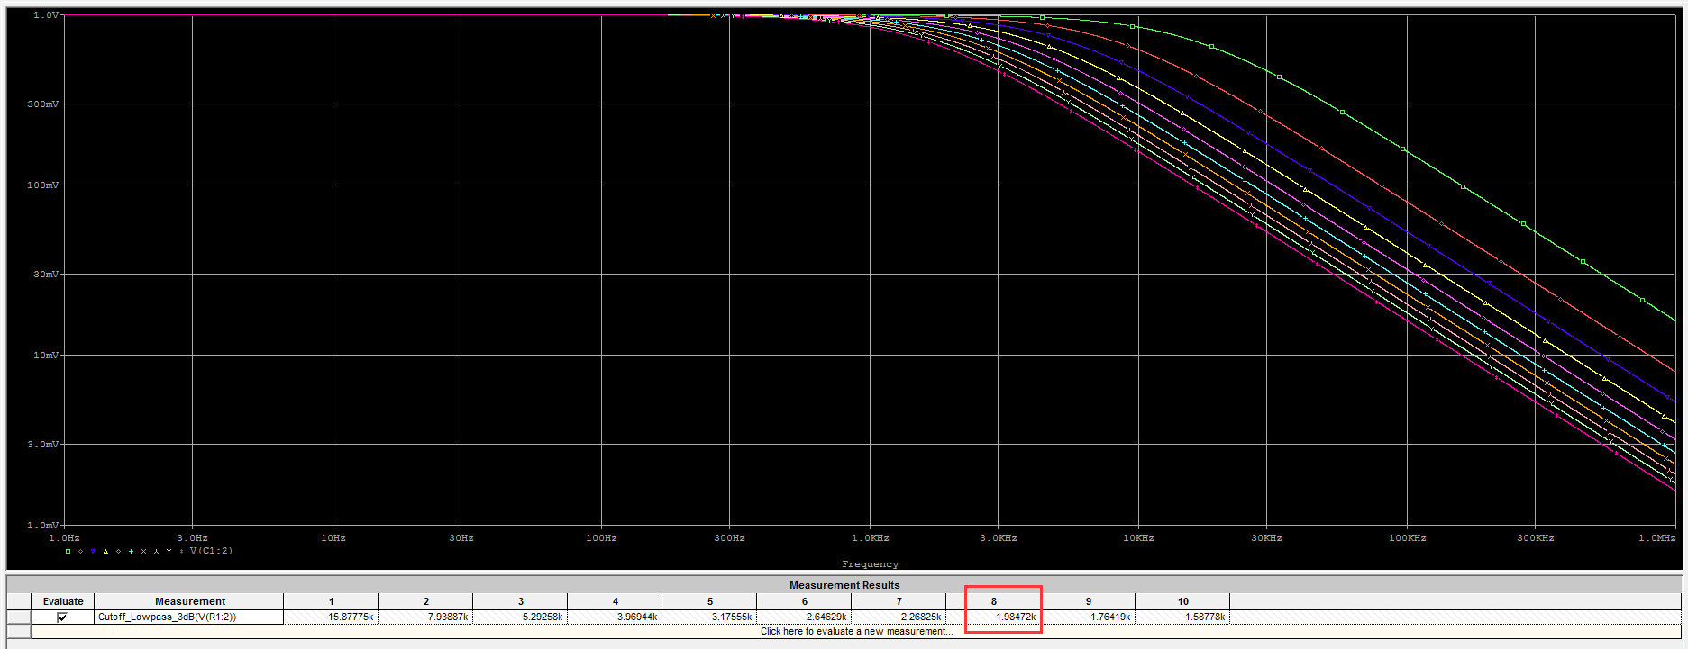

Also, the simulation prove this result. We can see that, when R=8K ohm, C=10 nF, our LP filter’s -3dB bandwidth is 1.98KHz.

### 4.2.2 ADC accuracy



Figure 4. The block chart of ADC’s Accuracy testing

We use the signal generator to simulate the Surface EMG signal, and sample it with our design ADC functional circuit and research grade EMG machine ----- Biosemi ActiveTwo at the same time. Assuming the EMG machine’s sampling result as the true value, we compare the result came from the ADC circuit with the true value, and calculate the error.

Since the SEMG’s amplitude is usually in the range of 20mV, so our input voltage should be within this range too.

Table 4. Sampling Accuracy record

|  |  |  |  |  |
| --- | --- | --- | --- | --- |
| Input voltage (mV) | True value from biosemi ActiveTwo (mV) | Sampling value from AD1299 (mV) | Error (mV) | Error ratio (%) |
| 1 |  |  |  |  |
| 2 |  |  |  |  |
| 4 |  |  |  |  |
| 6 |  |  |  |  |
| 8 |  |  |  |  |

### 4.2.3 Sampling stability

## Bluetooth Module Testing

## SD Card testing

## ACCELEROMETER testing